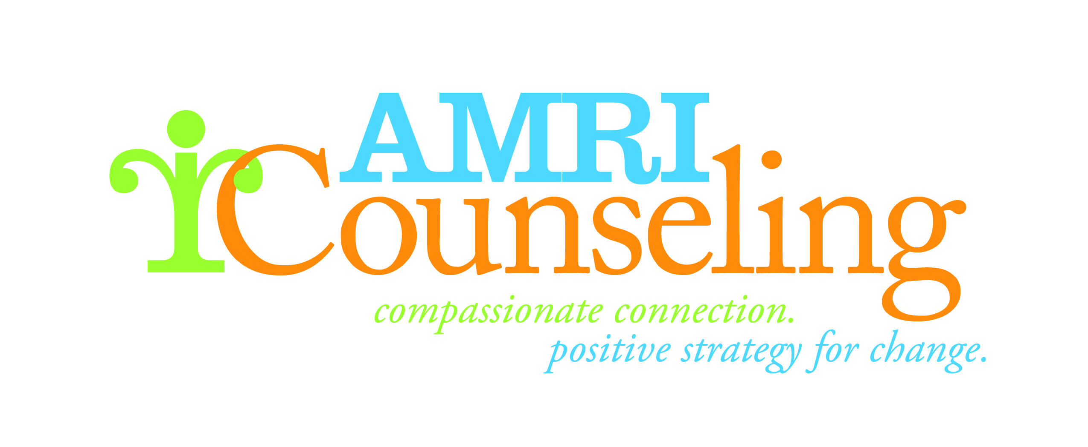
Questions?
Contact Ms. Lakeia Jones, CEO at (414) 810-6691 or
amricounseling@yahoo.com
Please complete information below and mail to:
AMRI Counseling Services
4001 W. Capitol Drive
Milwaukee, WI 53216
GIFT INFORMATION
Please accept my gift of: □ $1000 □ $500 □ $250 □ $100 □ $50 □ $25 □ Other: _________________

Become a sustaining member:
Please accept my monthly gift of $__________ Bill my credit card on the □ 5th □ 20th of each month for 12 months
Complete credit card information under “payment options” section

Please use my gift for: □ Area of greatest need
□ Counseling Fund – support for uninsured & underinsured
□ Support Services Fund – support for independent living & skills

Payment Options: Visa MC

CC# ________________________ Exp. Date______________ Gift Amount $__________
Name on card________________________________________________________________ CSC_________________

Check payable to: AMRI Counseling Services

DONOR INFORMATION

Name(s)_________________________________________________________________________________________________

Address______________________________________ City ___________________________ State ________ Zip ___________
Phone________________________________________ Email______________________________________________________

□ I/We would like this gift to remain anonymous

I/We would like to make today’s gift in □ Memory of □ Honor of:

Name___________________________________________________________________________________________________

□ Please notify the following person(s) of the gift:

Name__________________________________________________________________________________________________

Address________________________________________ City __________________________ State ________ Zip ___________

We do not share street/email address information with others.

Thank you for supporting AMRI Counseling Services.
Your contribution is tax deductible to the extent allowed by law.

